

**MEMORANDUM**

TO : All COPs

(Attn: Investigation Section)

FROM : Chief, PIDMU

SUBJECT : **Letter From Commander, Fleet Provost Marshal, Philippine Navy**

DATE : December 12, 2024

1. References:
2. Memorandum from C, RIDMD dated December 12, 2024 with subject same as above; and

b. Memorandum from TADIDM dated December 12, 2024.

2. This pertains to the letters from Commander Resuello, requesting assistant in implementing the alarm for the apprehension of Fireman Second Class (FN2) Paulo D. Rivera, FN2 Renan N. Gonzales, FN2 Marciano P. Abiul II, and FN2 Nhilbert John T. Mendrez.

3. In this regard, you are directed to immediately inform the Office of the Fleet Provost Marshal of any information regarding the whereabouts of the Philippine Navy personnel. Submit the result of your actions taken to this Office through email address: ldnppoinves@gmail.com **NLT 6:00 AM December 13, 2024**, for subsequent submission to the higher office.

4. For appropriate action.

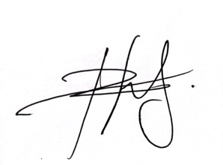

**RANDY A PONTANES**

Police Lieutenant Colonel